Propane brush drive housings (bearing housings):
E12709 used on propane burnishers (all) and XT3 21/27
E11344 used on rotating plate Big and Little Bertha Stripping Machines
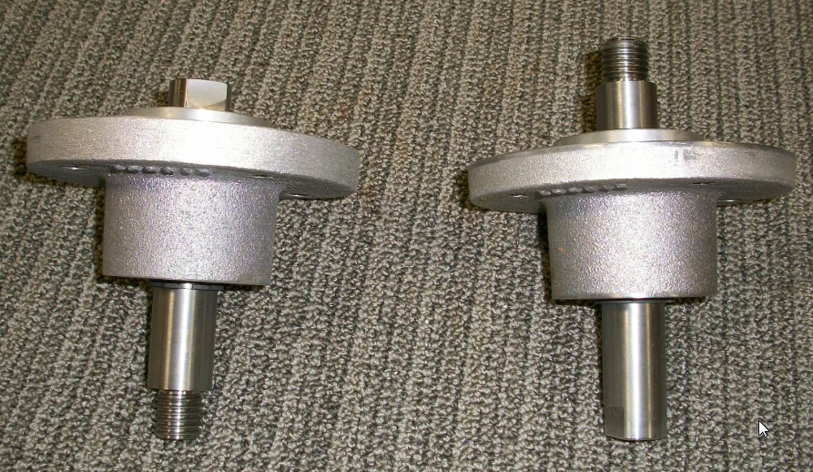
E11344
E12709

